Chapter 18

In this chapter you’ll use Django to build Learning Log, a simple web application that lets you keep track of information you’ve learned about particular topics. This section will help you get a virtual environment set up.

## Creating a Virtual Environment

To work with Django, it’s best to first set up a virtual environment. A virtual environment is a place on your system where you can install packages for one project and isolate those packages from the rest of your system. Using this approach, you can have many projects on your system without worrying about one project’s packages interfering with another project’s packages. Every project can have the exact version of the packages it needs, and you can update any one project’s packages without affecting your other projects.

To get set up for Learning Log, make sure you have an empty folder somewhere on your system called learning_log.

If you’re using Python 3, you should be able to create a virtual environment with the following command:

learning_log$ python -m venv ll_env

learning_log$

This command runs the venv module and uses it to create a virtual environment named ll_env.

If this works, move on to Activating the Virtual Environment. If it didn’t work, go to Installing virtualenv.

## Activating the Virtual Environment

Now that you have a virtual environment set up, you’ll need to activate it. On Linux and OS X, use the following command:

learning_log$ source ll_env/bin/activate

(ll_env)learning_log$

On Windows, run the following equivalent command:

learning_log> ll_env\Scripts\activate

(ll_env)learning_log>

This command runs the script activate, which is located in ll_env/bin. When the environment is active, you’ll see the name of the environment in parentheses. This means you can install packages to the environment and use packages that have already been installed. Packages you install in ll_env will be available only when the environment is active; if you run into errors, make sure you see (ll_env) in parentheses at the beginng of your terminal prompt. If you don’t see it, issue the activate command again.

###Deactivating the virtual environment

To stop using a virtual environment, enter **deactivate**:

(ll_env)learning_log$ deactivate

learning_log$

The environment will also become inactive if you close the terminal it’s running in.

## Installing virtualenv

If you’re using an earlier version of Python or if your system isn’t set up to use the venv module correctly, you can install the virtualenv package. To install virtualenv, enter the following:

$ pip install --user virtualenv.

You may use pip in a slightly different manner on your system; see installing Python Packages if you need help using pip.

If you’re using Linux and this still doesn’t work, you can install virtualenv through your system’s package manager. On Ubuntu, for example, the command **sudo apt-get install python-virtualenv** will install virtualenv.

### Creating a virtual environment with virtualenv

Change to the learning_log directory in a terminal, and create a virtual environment like this:

learning_log$ virtualenv ll_env

New python executable in ll_env/bin/python

Installing setuptools, pip...done.

learning_log$

If this works, move on to Activating the virtual environment.

If you have more than one version of Python installed on your system, you should specify the version for virtualenv to use. For example, the command **virtualenv ll_env –python=python3** wil create a virtual environment that uses Python 3.

## Installing Django

In an active virtual environment, you can use pip to install Django:

(ll_env)learning_log$ pip install Django

Installing collected packages: Django

Successfully installed Django

Cleaning up...

(ll_env)learning_log$

Because this command is run in a virtual environment, it’s the same on all operating systems. There’s no need to use the --user flag, and there’s no need to use longer commands like python -m pip install django.

Keep in mind that Django will only be available when the virtual environment is active.

### Installing a specific version of Django

Django 2.0 introduced some changes that affect the Learning Log project. The updates described below will allow you to run the project in the latest version of Django, but you can also install the previous version if you want to match what’s in the book exactly.

To do this, specify the version of Django you want to install when you use pip:

(ll_env)learning_log$ pip install Django==1.11

Collecting Django==1.11

Installing collected packages: pytz, Django

Successfully installed Django-1.11 pytz-2017.3

This should work even if you’ve already install a different version of Django. When you ask pip to install a specific version of a library, it will uninstall any other versions first.

## Updates

Django 2.0 was released recently, and there are a number of changes that affect the Learning Log project. The overall changes are described briefly, and then specific updates to the chapter are listed.

### Overview

Here’s an overview of recent changes to Django:

* Foreign keys need an explicit on_delete=models.CASCADE argument set. This was set by default in previous versions. When a user deletes a topic in their learning log, the on_delete argument tells Django what to do with the entries in that topic. The CASCADE value tells Django to delete any entries associated with a topic that’s being deleted.
* There’s a new way to define the namespace for an app’s URLs. Rather than setting the namespace in the project’s urls.py file, the namespace is set in each app’s urls.py.
* There’s a simpler approach to defining URLs. In previous versions, you had to write a regular expression for any URL that included an identifier, such as http://localhost:8000/topics/1/. This new approach is not required, but you’ll probably appreciate it and want to know about it.
* The reverse() function has been moved from django.core.urlresolvers to the django.urlsmodule.
* Django 2.0 only works with Python 3. If you’re still using Python 2.7, you’ll need to install Django 1.11.

### Checking which version of Django you’re using

The command pip freeze lists the specific versions of all packages you have installed in a virtual environment. To see which version of Django you’re using, make sure you’re in an active virtual environment, and then issue this command:

(ll_env)learning_log$ pip freeze

Django==2.0

pytz==2017.3

If you decide you’d rather use the previous version of Django so you can ignore these updates for now, you can install Django 1.11 as described above.

### Specific updates

Here are the specific changes to look out for in Chapter 17. It might look like there’s a lot of changes, but once you start working through the project you’ll see that many of these changes follow a consistent pattern. If you have any trouble with this that you can’t resolve, please reach out for help.

### p. 402, Figure 18-1

The default home page for a new Django project has been updated, and it’s beautiful!

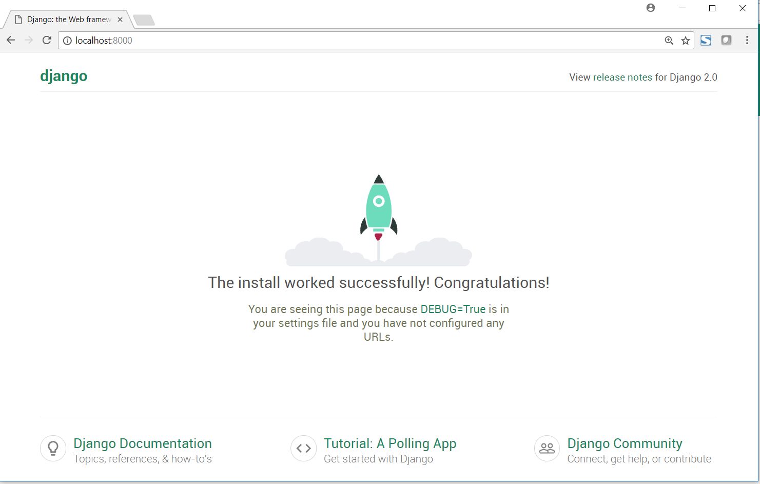

### p. 408, Defining the Entry Model

Replace the line that reads

topic = models.ForeignKey(Topic)

with

topic = models.ForeignKey(Topic, on_delete=models.CASCADE)

This tells Django that when a topic is deleted, all of the entries associated with that topic should be deleted as well. This is known as a cascading delete.

### p. 413, Mapping a URL

When you start a project in Django 2.0, this is what you’ll see in the project’s main urls.py file:

from django.contrib import admin

from django.urls import path

urlpatterns = [

path('admin/', admin.site.urls),

]

Django 2.0 introduces a new path() function that simplifies how we define URLs. The older url()approach still works, but in these updates I’ll show you how to use the new path() function.

Here’s how to include the URLs for the learning_logs app:

from django.urls import path, include

from django.contrib import admin

urlpatterns = [

path('admin/', admin.site.urls),

path('', include('learning_logs.urls')),

]

The include() function is now imported from the django.urls module. Since the new URL routing approach doesn’t require regular expressions, we don’t need to include a carat at the beginning of the URL string. We also don’t need to include a namespace argument in the include() call; that will be specified in the app’s urls.py in a moment.

Here’s what the learning_logs/urls.py file should look like:

"""Defines url patterns for learning_logs."""

from django.urls import path

from . import views

app_name = 'learning_logs'

urlpatterns = [

# Home page.

path('', views.index, name='index'),

]

We need to import the new path() function from django.urls. In Django 2.0, the app’s namespace is defined through an app_name variable in the app’s urls.py. Finally, the URL pattern for the home page is simpler without the need to define a regular expression.

### p. 419, The Topics URL Pattern

The topics URL pattern should look like this:

urlpatterns = [

--snip--

# Show all topics.

path('topics/', views.topics, name='topics'),

]

### p. 422, The Topic URL Pattern

The topic URL pattern should look like this:

urlpatterns = [

--snip--

# Detail page for a single topic.

path('topics/<int:topic_id>/', views.topic, name='topic'),

]

In this new path()-based approach you figure out what you want the URL to look like:

http://localhost:8000/topics/5/

Then you write this as a string, with any variables in the URL inside angle brackets. In the angle brackets you describe the type of variable to expect, int in this case, and provide a name for the value in the URL. This is much simpler than writing a regular expression to capture the value in the URL.

### Next

# Chapter 19

## Updates

### p. 429, The new_topic URL

The new_topic URL pattern should look like this:

urlpatterns = [

--snip--

# Page for adding a new topic.

path('new_topic/', views.new_topic, name='new_topic'),

]

The*new_topic()*View Function

The reverse() function has been moved to a different module, so its import statement has changed:

from django.shortcuts import render

from django.http import HttpResponseRedirect

from django.urls import reverse

### p. 433, The new_entry URL

The new_entry URL pattern should look like this:

urlpatterns = [

--snip--

# Page for adding a new entry.

path('new_entry/<int:topic_id>/', views.new_entry, name='new_entry'),

]

### p. 436, The edit_entry URL

The edit_entry URL pattern should look like this:

urlpatterns = [

--snip--

# Page for editing an entry.

path('edit_entry/<int:entry_id>/', views.edit_entry, name='edit_entry'),

]

### p. 439, Including the URLs from users

The line to include the URLs from the users app should look like this:

from django.urls import path, include

from django.contrib import admin

urlpatterns = [

path('admin/', admin.site.urls),

path('users/', include('users.urls')),

path('', include('learning_logs.urls')),

]

As we saw when including the URLs from learning_logs, we write a simple string for the base of the URL, 'users/'. We leave out the namespace argument, because the namespace will be defined in the users/urls.py file.

### p. 440, The Login Page

The users/urls.py file should look like this:

"""Defines url patterns for users."""

from django.urls import path

from django.contrib.auth.views import login

from . import views

app_name = 'users'

urlpatterns = [

# Login page.

path('login/', login, {'template_name': 'users/login.html'},

name='login'),

]

Here we’ve defined the app_name variable, which defines the namespace for the URLs associated with the users app. We’ve also used the path() function to define the URL pattern for the login page.

### p. 442, The logout URL

The logout URL pattern should look like this:

urlpatterns = [

--snip--

# Logout page.

path('logout/', views.logout_view, name='logout'),

]

### p. 442-3, The*logout_view()*View Function

In users/views.py, the reverse() function needs to be imported from django.urls:

from django.urls import reverse

### p. 444, The register URL

The register URL should look like this:

urlpatterns = [

--snip--

# Registration page.

path('register/', views.register, name='register'),

]

### p. 449, Modifying the Topic Model

In learning_logs/models.py, the line that defines the foreign key relationship between topics and users should look like this:

owner = models.ForeignKey(User, on_delete=models.CASCADE)

This tells Django that when a user is deleted, all of the topics owned by that user should be deleted as well.